F-751 Avocado Quality Meter AvoAI Update Instructions
The below instructions should be followed step-by-step to successfully update an existing F-751 Avocado Quality Meter to the newest AvoAI app update.
**It is important to note that the F-751 Avocado Quality Meter SD card must only be accessed using a Windows PC.**
Inserting the SD card into a macOS computer can automatically create hidden system files (for example .DS_Store, ._files, and Spotlight indexing files). These hidden files may interfere with the AvoAI application and can cause workflow configuration errors or prevent the software from operating correctly.
Update Instructions:
- Download the SDCardTemplate.zip file from the F-751 Avocado Quality Meter Support Page. This is located in the Downloads tab.
- With the device powered off, remove the SD card from the SD card slot and insert it into a PC.
- Back up the entire contents of the SD card to a secure drive on your PC.
- Delete all files from the SD card.
- Format the SD card using FAT32 formatting.
  - To do this, right click on the SD card drive in the file explorer, choose Format, then under “File System” select FAT32 from the dropdown menu, then press OK.
- From the contents you backed up in Step 3, copy only the F-75XSettings F-751-XXX-XXXXX.txt file, then paste it into the root directory of the SD card.
- Extract the files from the SDCardTemplate.zip file you downloaded in Step 1.
- Copy all files from the SDCardTemplate.zip file and paste them into the root directory of the SD card.
- Your SD Card’s root directory should now look like this:
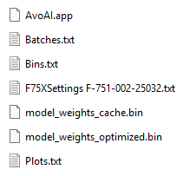
- You are free to open, customize, and save the Batches.txt, Bins.txt, and Plots.txt files to align with your operation’s current sample naming/labeling conventions.
- All other files must not be opened, changed, or removed from the SD card. Doing so will result in device errors or prevent the AvoAI app from operating.
- You can now safely eject your SD card from your PC and insert it back into your F-751 Avocado Quality Meter.
- Power your F-751Avocado Quality Meter on. After a brief warm-up period, the screen should display similarly to the below:
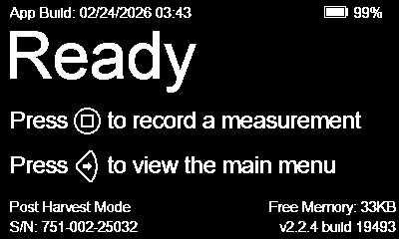
- Consult the user manual and UI walkthrough video to learn more about the new features of the AvoAI app update.
If you encounter issues during the updating process, please reach out to the Felix Instruments Support Team via email or phone:
support@felixinstruments.com
+1 (360) 833-8835

